What is going on in schools – risks/rights
The resources below are intended to inform you of the risks in the Nassau County School System. Parents, citizens and students should be aware of potentially harmful curriculum, handouts, surveys and videos that are not education focused but are potentially harmful and not suitable for presentation in schools.
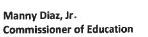  Letter to Florida District Superintendents & Charter School Operators | SEL Content has no place in Florida’s Classrooms  Click to read the full letter. All SEL content should be scrutinized.
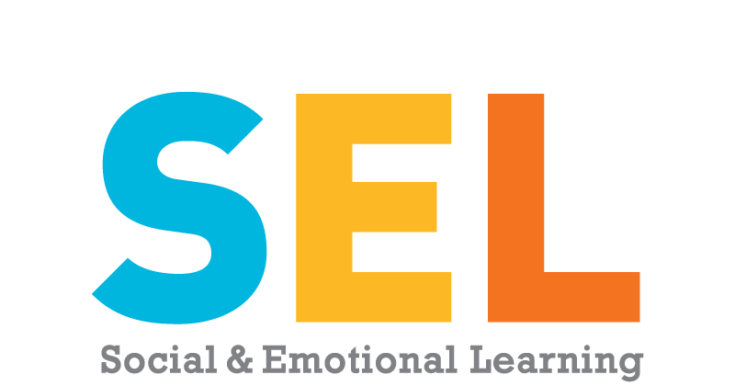  SEL's most visible primary drivers are the World Health Organization, CDC, World Economic Forum, American Research Association, the American School Counseling Association, and the Bill Gates Foundation. (CASEL) |  | Social Emotional Learning - SEL  Pioneer Institute Study  SEL is insulting to parents.  Soros organization and SEL  CASEL  In the context of SEL, equity and excellence refers to every student—across race, ethnicity, family income levels, learning abilities, home language, immigration status, gender identity, sexual orientation, and other factors
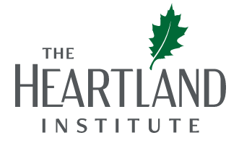 |  | Failing Schools – National Crisis (facts)  NEA - teachers unions assembly  NBI 4 asserts, “The NEA will inform states and locals of the following sample language that may be put in contracts and policies that is LGBTQIA+ inclusive. The language will be as follows: ‘Parental leave’ instead of ‘maternity leave,’ ‘parent’ instead of ‘mother’ or ‘father,’ ‘birthing parent’ instead of ‘mother’ or ‘father,’ and ‘non-birthing parent’ instead of ‘mother’ or ‘father.’”
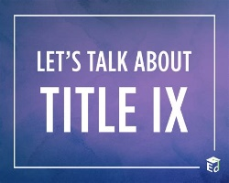 |  | Federal initiatives such as Title IX changes  Boys playing in girls sports, sharing bathrooms
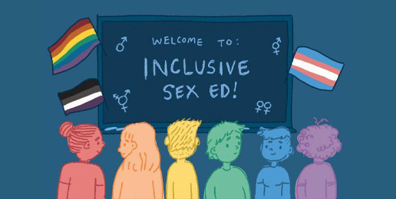 |  | Sex Education in public schools  Know our local sex ed curriculum
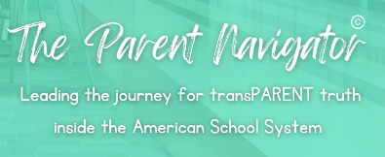 |  | The Parent Navigator (Online book - $22)  Excellent 200 page resource explaining school issues simply and clearly

