1 J **SL1**

Caps *Lock*



# ACCREDITATION FAILURE

ILLEGAL ELECTRONIC VOTING MACHINES/DEVICES

HAVA established the Election Assistance Commission (EAC)

EAC developed the EAC’s Voting System Test Laboratory Accreditation Program 52 USC §20971 EAC’s Voting System Test Laboratory Accreditation Program Manual

<https://www.eac.gov/> sites/ default/ files/ eac_assets/ l/28/VSTLManual%207%208%2015%20FINAL

.pdf

Pro V&V and SLI Compliance, per the EAC, were the only two accredited Voting System Test Laboratory (VSTL)

VSTLs are responsible for the examination of the use of Commercial Off-The-Shelf (COTS) components

Help America Vote Act 2002

## Voting System Test Laboratory

**Program Manuel**

* Voting System Test Laboratory Program Manuel ver. 2.0 pg. 38 of Sec. 3.6.1 Certificate of Accreditation: A Certificate of Accreditation shall be issued to each laboratory by vote of the Commissioners. The certificate shall be signed by the CHAIR of the Commission and state:
* “The effective date of the certification, which shall not exceed a period of two (2) years ”

□ Not just the date is important but the signature on the Lab Certification of Accreditation is very crucial.



* + 1. Certificate of Accreditation. A Certificate of Accreditation shall be issued to each laboratory accredited by vote of the Commissioners. The certificate shall be signed by the Chair of the Commission and state:
       1. The name of the VSTL;
       2. The scope of accreditation, by stating the Federal standard or standards to which the VSTL is competent to test;
       3. The effective date of the certification, which shall not exceed a period of two (2) years; and
       4. The technical standards to which the laboratory was accredited.

# EAC Commission

u s- ELECT,ON

ASSISTANCE CoMMISSIoN

Need Help?

# Chairman

Commission Chairman only serves one (1) year, but their signature is good on these certificates for two (2) years.

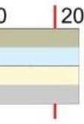Both Donald Palmer AND Benjamin Hovland were appointed by President Trump and confirmed in the senate on Feb. 4, 2019, as EAC Commissioners but not Chairman.

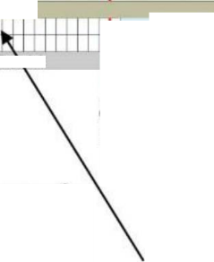

Home > News > Commissioners Hovland, Palmer Sworn In to Restore Quorum at EAC

Media

NEWS

COMMISSIONERS HOVLAND, PALMER SWORN IN TO RESTORE QUORUM AT EAC

**EAC Commissioners**

[https://www.eac.gov/ news/2019/02/06/commissioners-](https://www.eac.gov/_news/2019/02/06/commissioners-hovland-palmer-sworn-restore-quorum-eac)

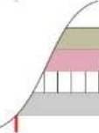2016 | 2017 | 2018

**I Thomas Hi**

2019 I

[hovland-palmer-sworn-restore-quorum-eac](https://www.eac.gov/_news/2019/02/06/commissioners-hovland-palmer-sworn-restore-quorum-eac)

A vote for a VSTL’s reaccreditation is taken by the EAC and

**Matthew V Materson**

•T

**24 Feb 2017 PRO V&V**

**VSTL Accreditation**

Expires

Tl*l

**Christy A IcCortpick**

**Donald Palmer Benjamin Hovland**

i i

**6 Feb 2019 Sworn In**

Full quorum Commissioners since 2019

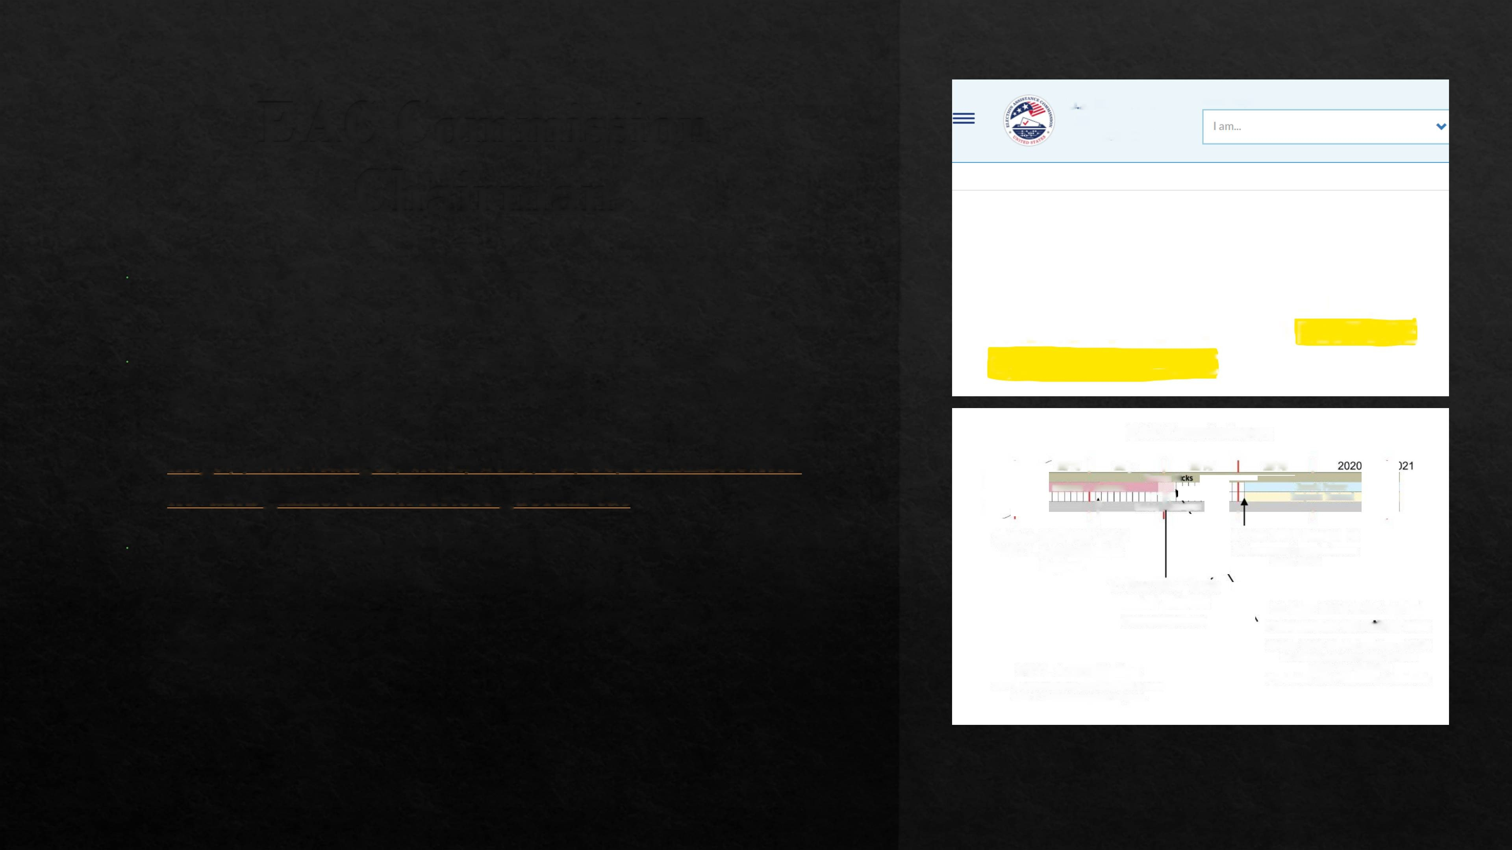shall be passed by a vote of (3) three commissioners. The

EAC did not met quorum for the year of 2018 due to only having (2) commissioners.

**12 Dec 2017 Term ended without renomination**

**VSTL Accreditation**

VSTL Accreditation REQUIRES a vote with 3 Commissioners to pass

**23 Mar 2018 EAC stated resignation effective date**

26 Mar 2018 Started position at DHS as senior cybersecurity advisor within the National

Protection and Programs Directorate

#### ProV&V - EAC Certification Issues #1

ProV&V EAC Certification, Original Issued February 24, 2015,

Dated February 21, 2021. (Exceeding, more than two (2) years

- Not signed by Chair of Commission)

The EAC did not met quorum for the year of 2018 due to only having

(2) commissioners for the accreditation to be legal and valid.

No VSTLs were properly accredited for the 2020 Presidential election on November 3, 2020, and

continue to be unaccredited due to lack of compliance.

F

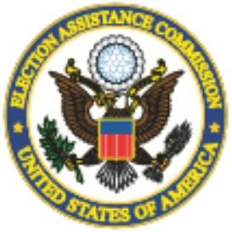**United States Election Assistance Commission**

**Certificate of Accreditation**

Pro V&V, Inc.

**Huntsville, Alabama**

*is recognized by the U.S. Election Assistance Commission for the testing of voting systems to the 2005 Voluntary’ Voting Systems Guidelines under the criteria set forth in the E4C Voting System Testing and Certification Program and Laboratory Accreditation Program. Pro V&V is also recognized as having successfully completed assessments by the National Voluntary Laboratory Accreditation Program for conformance to the requirements ofISOlEC 17025 and the criteria set forth in NIST Handbooks 150 and 150-22.*

***Effective Through***

Date: 2 24.15

February 24: 2017 ***Acting Executive Director, U.S. Election Assistance Commission***

EAC Lab Code: 1501

#### SLI Compliance - EAC Certification Issues # 1

SLI Compliance Certification Issued January 10, 2018, Effective

January 10, 2021. (Exceeding, more than two (2) years - Should be signed by Chair of Commission)

The EAC did not met quorum for the year of 2018 due to only having

(2) commissioners for the accreditation to be legal and valid.

’S

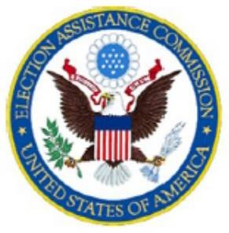**United States Election Assistance Commission**

20

**Certificate of Accreditation SLI Compliance,**

**Division of Gaining Laboratories International, LLC W heat Ridge, Colorado**

*is recognized by the U.S. Election Assistance Commission for the testing of voting systems to the 2002 Voting Systems Standards, the Voluntary Voting Systems Guidelines versions 1.0 and 1.1 under the criteria set forth in the EAC Voting System Testing and Certification Program and Laboratory Accreditation Program. SLI Compliance is also recognized as having successfidly completed assessments by the National Voluntary Laboratory Accreditation Program for conformance to the requirements of ISO/IEC17025 and the criteria set forth in NIST Handbooks 150 and 150-22.*

No VSTLs were properly accredited

***Effective Through***

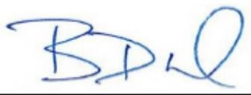January' 10, 2021 ***Brian Newby,***

Date: 1/10/18

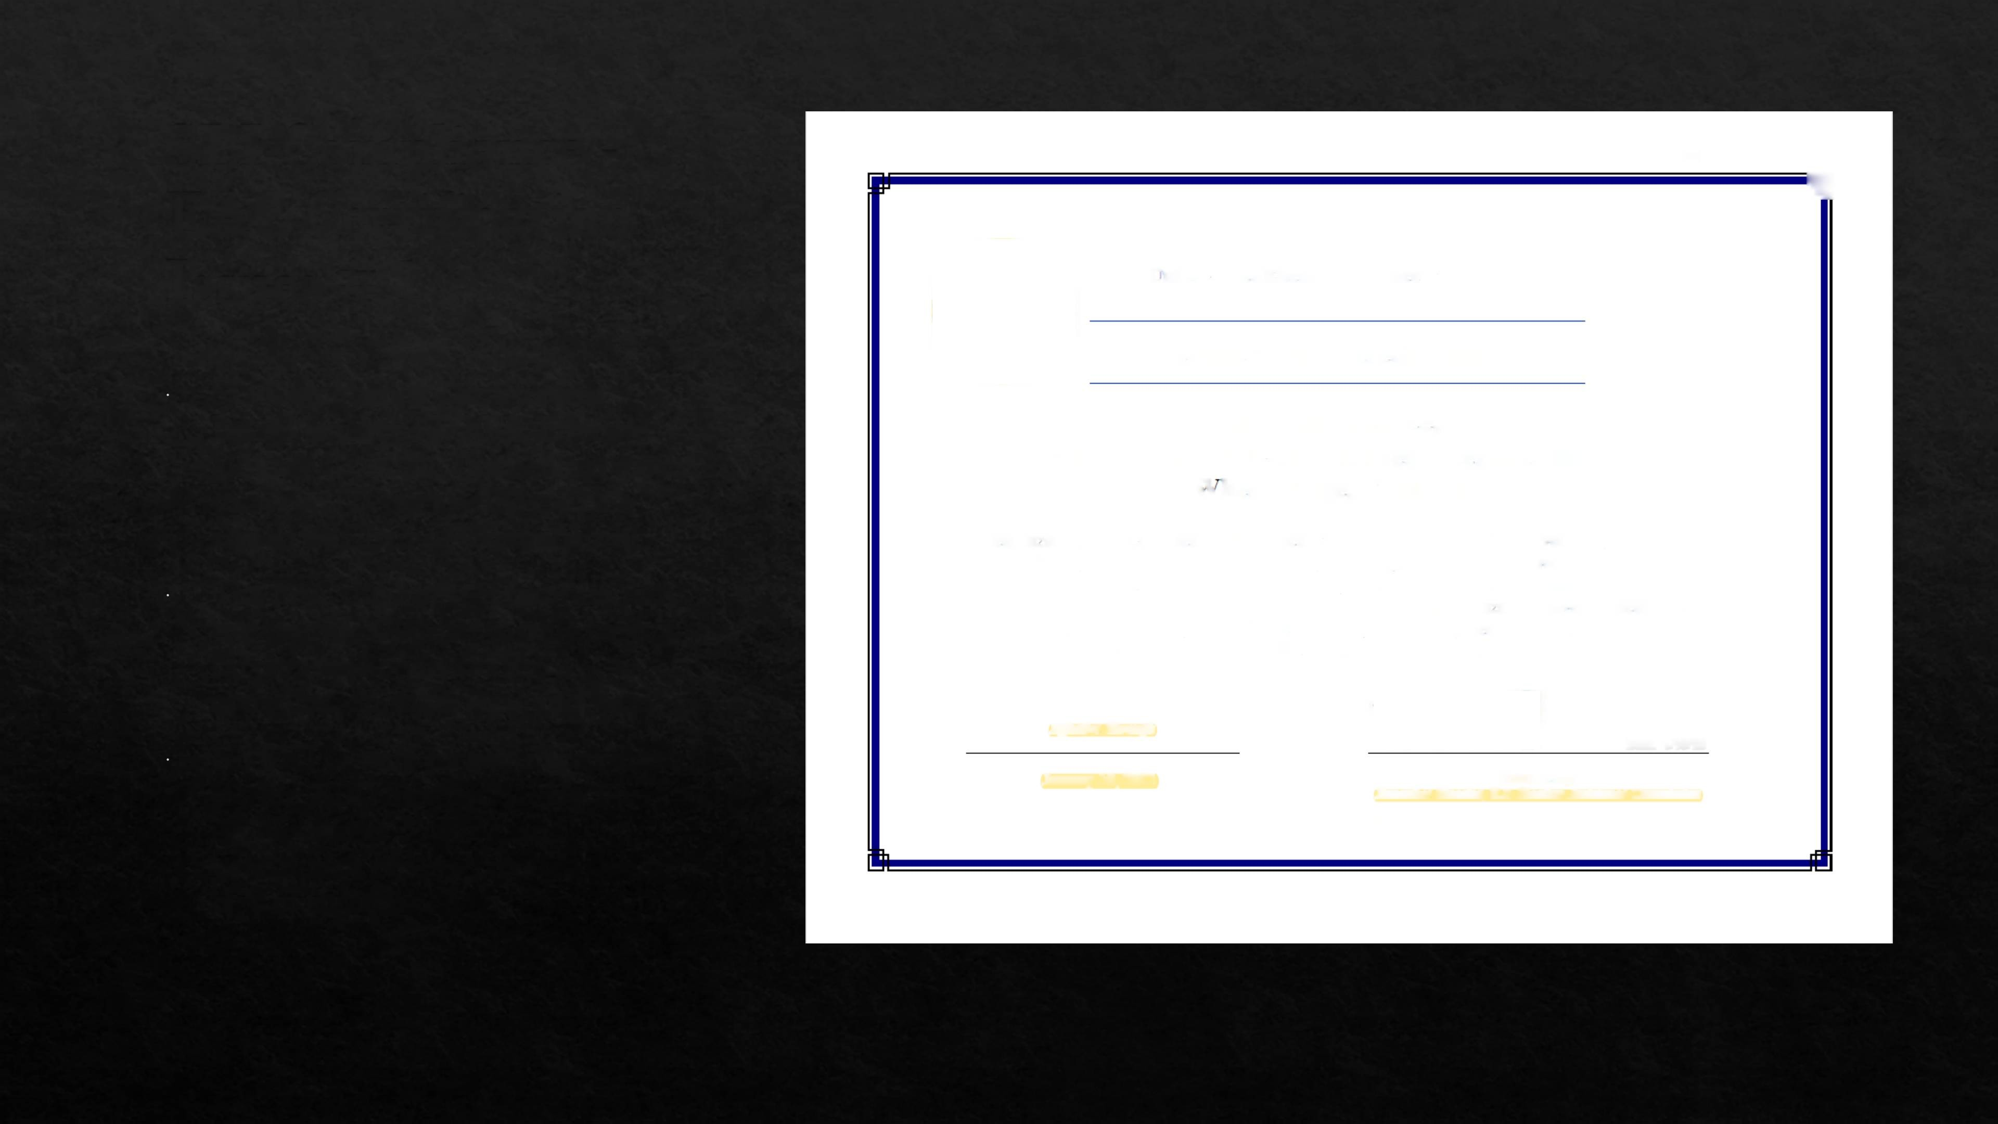for the 2020 Presidential election on November 3, 2020, and continue to be unaccredited due to lack of compliance.

***Executive Director, U.S. Election Assistance Commission***

EAC Lab Code: 0701

#### ProV&V And SLI EAC Certification Issues # 2

EAC provided the following for SLI Compliance and Pro V&V dated January 21, 2021, stating Covid-19 circumstances as the reason why the accreditation was/is not in accordance to VSTL Version 2.0 Section 3.8. This is false as the accreditation expired in 2017/2018. (“PRE” Covid-19 pandemic)

[https://www.eac.gov/ sites/default/ files/voting](https://www.eac.gov/_sites/default/_files/voting) system test lab/files/SLI Compliance Accredi tation Renewal delay memoOl 2721.pdf <https://www.eac.gov/> sites/default/ files/voting system test lab/files/Pro VandV Accreditatio n Renewal delay memo012721.pdf

**U.S.** ELeCTion AssisTAnCe Commission

£13 3rd St Surft? W

**IFs** DC JfiWJ

**FftOM:** Jerome Lovato, Voting System Testing and Certification Director

**SUBJECT:** Pro V&V EAC VSTiL Accreditation

**DATE:** 1/27/2021

Pro V&V has completed all requirements to remain in good standing with the EACs Testing and Certification program per section 3.8 of the Voting System Test Laboratory Manual version 2.0:

Expiration end ffenewaf of Accredits fiort A grant *of accreditation is valid for a period* not to exceed two years. A VS TVs accreditation expires an the date onaotafed on the Cerh/icofe *of Accreditation* VSTLs in good standing sholf renew their accreditation by Submitting on appiicatian package to the Program Director, consistent with the procedwres of Section 3.4 of this Chapter no eadier than 60 days before the accreditation expiration dote and no later than 30 days before* that date Laboratories that firne/y file the renewal application package shad retain their acrreddotrori while the

review and processing of their application is pending. VSTLs in good standing shah also retain their accredifotiarr should circumstances ieoi/e the EM without a quorum ta conduct the vote required under Section 3.5.5.

Due to the outstanding circumstances posed by COVID-19, the renewal process for EAC laboratories has bean delayed (or an extended period. While this process continues, Pro v&v retains its EAC VSTL accreditation.

## ProV&V And SLI EAC Certification Issues # 3

July 22. 2021 the EAC states both Pro V&V and SLI Compliance VSTL another excuse regarding the lack of proper and legal accreditations. 52 USC §20971(c)(2)

[https://www.eac.gov/voting-equipment/voting-system-tesulaboratories-vstl/ prow](https://www.eac.gov/voting-equipment/voting-system-tesulaboratories-vstl/_prow) <https://www.eac.gov/voting-equipment/voting-system-test/aboratories-vstl/> sli-compliance-division- gaming-laboratories

* 52 U.S. Code § 20971(c)(2) is not applicable to the effective date of the accreditation as the accreditation EXCEEDED the period of two (2) years. The statute does not refer to continued accreditation due to any failure of action as to “revoke” is to “take away” not extend.

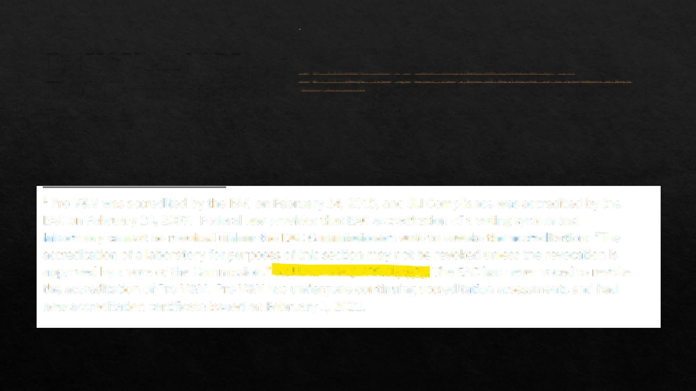

1 Pro V&V was accredited by the EAC on February 24, 2015, and SLI Compliance was accredited by the EAC on February *28,* 2007. Federal law provides that EAC accreditation of a voting system test **laboratory cannot be revoked unless the EAC Commissioners vote to revoke the accreditation: "'The** accreditation of a laboratory for purposes of this section may not be revoked unless the revocation is approved by a vote of the Commission," 52 U.S, Code § 20971(c)(2), The EAC has never voted to revoke the accreditation of Pro V&V. Pro V&V has undergone continuing accreditation assessments and had new accreditation certificate issued on February 1, 2021.



# Pro V&V And SLI EAC

Certification Issues # 4

Noted is the same document above provides another excuse as to why the VSTLs are not properly accredited. Accordingly, the “Accardi” decision requires that even governmental officials must follow agency regulations and guidelines.

By the EAC’s own admission of “administrative error”; the foundation of the rule of law under the Accardi doctrine; the EAC did not observe their own rules and guidelines, therefore violating the laws set by HAVA affording a domino effect to the State of Texas.

Due to administrative error during 2017-2019, the EAC did not issue an updated certificate to Pro V&V causing confusion with some people concerning their good standing status. Even though the EAC failed to reissue the certificate, Pro V&V's audit was completed in 2018 and again in early 2021 as the scheduled audit of Pro V&V in 2020 was postponed due to COVID-19 travel restrictions. Despite the challenges outlined above, throughout this period, Pro V&V and SLI Compliance remained in good standing with the requirements of our program and retained their accreditation. In addition, the EAC

has placed appropriate procedures and qualified staff to oversee this aspect of the program ensuring the continued quality monitoring of the Testing and Certification program is robust and in place.

### Texas Codified HAVA2002

1. 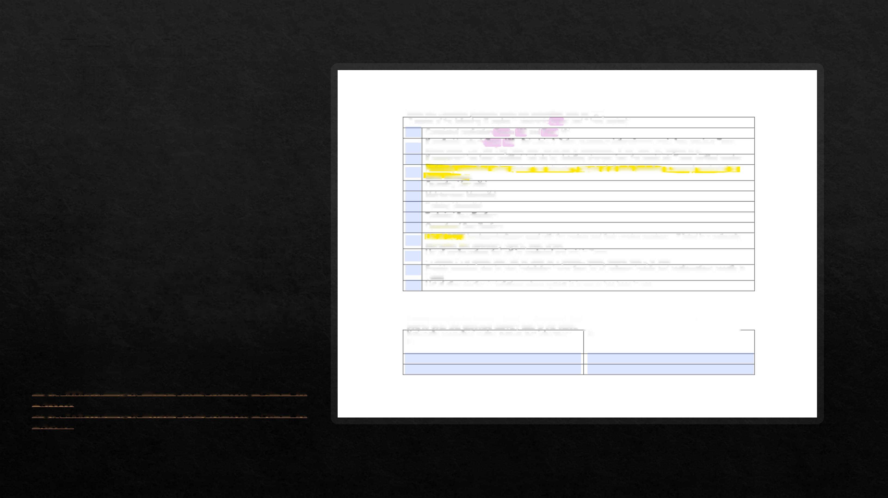“The Secretary of State requires new systems and modifications to previously-certified systems be qualified by the Election Assistance Commission (EAC), with 2002 Voting System Standards/guidelines (VSSG) or newer, prior to being submitted for examination.”
2. “The vendor applying for certification must complete and deliver application forms (Form 100, Form 101, and if applicable, Form 100 Schedule A), user operating and maintenance manuals, training material, final report(s) from an independent testing laboratory accredited by the EAC, a change log detailing changes from any previously-certified system or component, and application fee(s), to the Secretary of State no later than 45 days prior to examination.”

[https://www.sos.texas.gov/ elections/forms/formlOO.pdf#search=for](https://www.sos.texas.gov/_elections/forms/formlOO.pdf%2523search%3Dfor) m%20100

<https://www.sos.texas.gov/> elections/forms/form 101.pdf#search=for m%20101

**Materials Checklist (Indicate materials submitted with an “X”)**

|  |  |
| --- | --- |
| 7 copies of the following (5 copies in electronic format and 2 hard copies): | |
|  | Completed application Forms 100 and Form 101 |
|  | If applicable, attach Form 100 - Schedule A, listing recommendations/issues made from previous Texas  examination. List how they have been corrected or addressed. If the have not, explain why. |
|  | If component has been modified, include log detailing changes from the previously Texas certified version |
|  | Nationally accredited voting system test laboratory reports of all tests (including summary) conducted on items submitted |
|  | Operating Manual(s) |
|  | Maintenance Manual(s) |
|  | Training Manual(s) |
|  | Technical Specifications |
|  | Operational Specifications |
|  | List all COTS hardware/software used with the system and their version numbers - If listed in a nationally accredited test laboratory reports, state where |
|  | List all configurations that will be marketed and sold in Texas  - indicate if the optical scan will be used as a precinct count, central count, or both |
|  | Provide complete step-by-step installation instructions for all software installs and configurations specific to Texas |
|  | List of other election jurisdictions where system is in use or has been in use |

**Acknowledge which voting system test laboratory has been notified to send a copy of the software and source code and expected delivery date to our office.**

|  |  |
| --- | --- |
| **Nationally accredited voting system test laboratory**  **Name** | **Delivery Date** |
|  |  |
|  |  |

### Election Voting Systems/D evices are not legal certified

The EAC did not hold quorum in accordance with federal law therefore the “testing” laboratories VSTLs accreditations are not valid under HAVA 2002 federal statute.

Accordingly, the Accardi decision requires that even government officials MUST following agency regulations and guidelines.

52 USC §20971(c)(2) the action to revoke is to take away not extend.

Texas codified HAVA 2002 accreditation into Texas Election code in order to be utilized in the State of Texas. Tex. Admin. § 81.61, Tex. Elec § 122.01

Any electronic voting system MUST be certified by an ACCRED1TAED VSTL.

# Your Vote Belongs to YOU!

Quorum would have needed to be held well before any real or perceived complications due to COVID-19. There was no quorum in 2018.

Accreditation would not have been possible in order to be in accordance with HAVA of 2002 Section 231(b) and the Voluntary Voting System Guidelines in clear violation of law.

Accreditation and certification are used in many aspects of our society. For example, universities and colleges are accredited by private agencies known as an accrediting agency or accreditor.

Imagine the public response if colleges and universities turn out to not be accredited due to an accreditor’s lack of credentials and the diploma is not valid.

Due to the lack of accreditation - Did your vote count as a “legal” vote? Are any of the elections since 2020 legal and valid elections?